**USER MANUAL**

### Creating the Database Tables

When an address book, the obvious fields come to mind—name, glasses, customer name number, email address,wastage report However, it look at own paper-based address book, may note that have several entries for one person. Maybe that person has three telephone numbers, or two email addresses, and so forth. In online address book, a set of related tables will help alleviate the redundancy and repetition of information.

shows sample table and field names to use for online address book. In a minute, will create the actual SQL statements, but first should look at this information and try to see the relationships appear. The fields should be primary or unique keys.

As it can see in the following SQL statements, the master\_name table has two fields besides the ID and date-related fields: f\_name and l\_name, for first name and last name. The id field is the primary key. No other keys need to be primary or unique, it is really want to limit address book to one John Smith, one Mary Jones, and so forth.

The field lengths for the text fields in the following statements are arbitrary; it can make as long or as short as want, within the allowable definition of the field type.

**Learning Basic SQL Commands:**

The OLAP Services feature available in SQL Server version 7.0 is now called SQL Server 2000 Analysis Services. The term OLAP Services has been replaced with the term Analysis Services. Analysis Services also includes a new data mining component. The Repository component available in SQL Server version 7.0 is now called Microsoft SQL Server 2000 Meta Data Services. References to the component now use the term Meta Data Services. The term repository is used only in reference to the repository engine within Meta Data Services

SQL-SERVER database consist of six type of objects,

They are,

1. TABLE

2. QUERY

3. FORM

4. REPORT

5. MACRO

**TABLE:**

A database is a collection of data about a specific topic.

**VIEWS OF TABLE:**

We can work with a table in two types,

1. Design View

2. Datasheet View

**Design View**

To build or modify the structure of a table we work in the table design view. We can specify what kind of data will be hold.

**Datasheet View**

To add, edit or analyses the data itself we work in tables datasheet view mode.

**QUERY:**

A query is a question that has to be asked the data. Access gathers data that answers the question from one or more table. The data that make up the answer is either dynaset (if you edit it) or a snapshot (it cannot be edited).Each time we run query, we get latest information in the dynaset. Access either displays the dynaset or snapshot for us to view or perform an action on it, such as deleting or updating.

**Microsoft SQL Server**

To launch Microsoft SQL Server, click Start -> Programs -> Microsoft SQL Server 2005 -> SQL Server Management Studio.

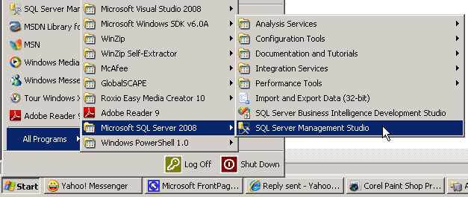

When it starts, it would present a dialog box that expects you to log in.

|  |
| --- |
| **Introduction to Code** |

Although you will perform many of your database operations visually, some other operations will require that you write code. To assist with this, Microsoft SQL Server provides a code editor and various code templates.

To open the editor:

* On the main menu, you can click File -> New -> Query With Current Connection
* On the Standard toolbar, click the New Query button New Query
* In the Object Explorer, right-click the name of the server and click New Query

This would create a new window and position it on the right side of the interface.

|  |
| --- |
| **Executing a Statement** |

In the next sections and lessons, we will learn various techniques of creating SQL statements with code. By default, when a new query window appears, it is made of a wide white area where you write your statements:

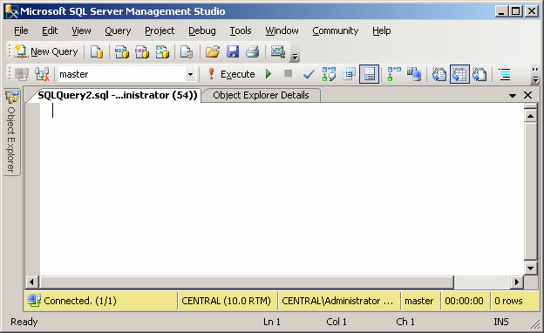

After writing a statement, you can execute it, either to make it active or simply to test it. To execute a statement:

* You can press F5
* On the main menu, you can click Query -> Execute
* On the SQL Editor grey_loader

toolbar, you can click the Execute button Execute

* You can right-click somewhere in the code editor and click Execute

When you execute code, code editor becomes divided into two horizontal sections:

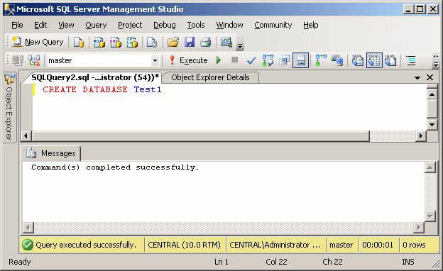

Whether you have already written code or not, you can save the document of the code editor at any time. To save it:

* You can press Ctrl + S
* On the main menu, you can click File -> Save SQLQueryX.sql...
* On the Standard toolbar, you can click the Save button Save

|  |  |
| --- | --- |
| 1. In the Object Explorer, right-click Databases and click New Database...   New Database 2. In the Name text box, type **MotorVehicleAdministration** |  |

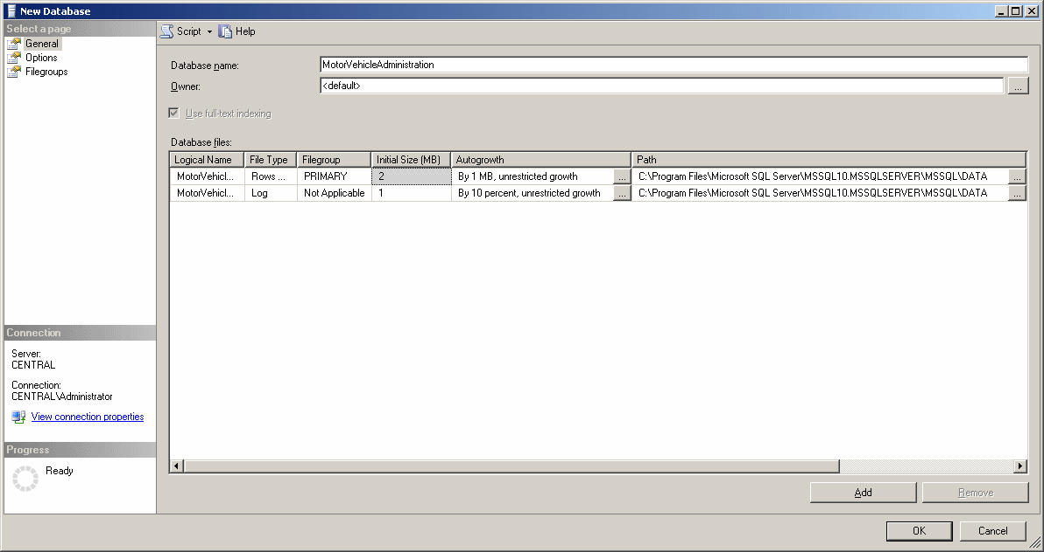

|  |  |  |  |
| --- | --- | --- | --- |
| |  | | --- | |  | | | |
| **Creating a Table** |

1. In the Object Explorer, expand the BCR node (click its + button)

Under BCR, right-click Tables and click New Table...